Project Design Phase-II
Technology Stack (Architecture & Stack)

Date | 26-11-2025
Name | Sathish kumar s
Project Name | DocSpot – Doctor Appointment Booking System
Maximum Marks | 4 Marks

Technical Architecture:
The DocSpot platform is designed using a scalable 3-tier architecture, ensuring efficient appointment management, real-time availability, and secure interactions between patients, doctors, and administrators.
The system consists of:
- Presentation Layer (Frontend)
- Provides user interfaces for patients, doctors, and admin.
- Supports responsive and intuitive UI for appointment booking and schedule management.

- Application Layer (Backend / Business Logic)
- Handles authentication, appointment creation, schedule updates, and admin operations.
- Exposes RESTful APIs for frontend communication.

- Data Layer (Database)
- Stores users, doctors, appointments, availability slots, and system logs.
- Ensures secure and structured storage for all data entities.
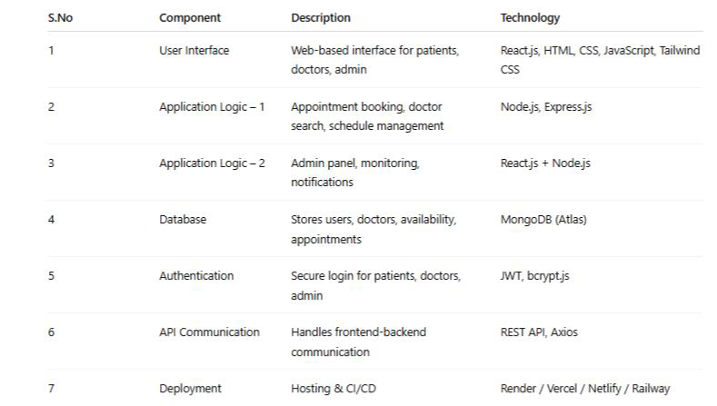
Table-1 : Components & Technologies:

Table-2: Application Characteristics:
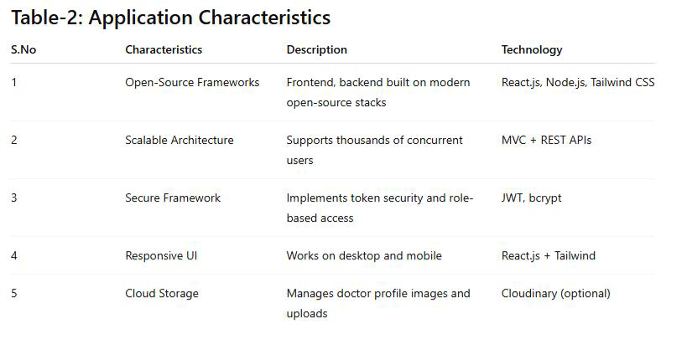
References:

React.js Documentation
Node js Best Practice
JSON Web Server Referance

